Hard Drive Spacers project
See below diagram which is a very rough draft for a pair of hard drive spacers. Your task as students is to draw it on A3 paper (TWO SHEETS, READ OVERPAGE) with plan, two elevations and isometric view, and then fabricate the spacers with galbond or zincalume 0.7mm sheet metal.
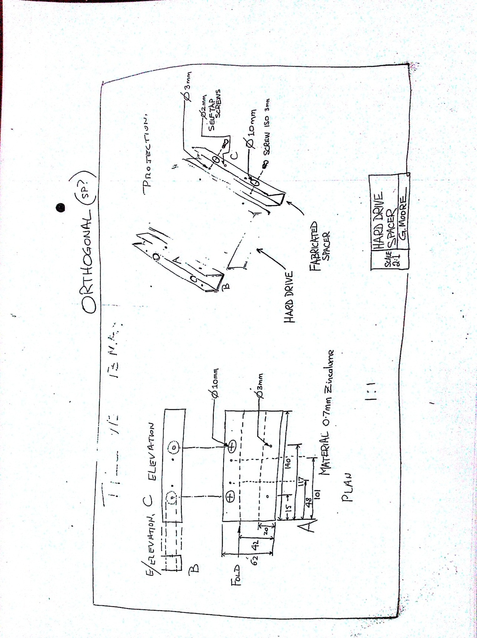
The material for fabrication is galbond. Ask your teacher for a view of the samples if you are unsure. Please see the power points about critical bending and other aspects.
Points for the drawing…
The plan view, front elevation and the end view are drawn to scale, 1:1
The isometric view will be drawn on a second sheet of paper at 2:1 proportional size and, if needed, truncated, and the hard drive shown also in truncated view. All circles will be drawn here in professional isometric style with guidelines still showing in 2B pencil. The small screws etc will be shown and annotated on the drawing.

Points for the construction
Do watch the powerpoint and any video which is available
Do use the right metal
Do take time to think about symmetry
Do use a fine pen for marking out your metal
Do use border and name box on each drawing sheet

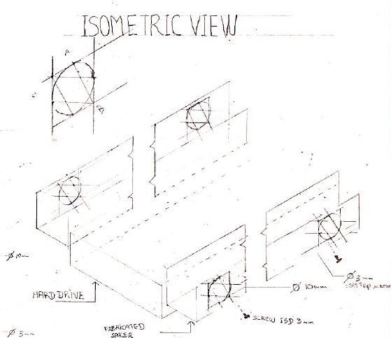 Some ideas shown here to help you
